14.1.10 Editors - Movie Clip Editor - Header - Mask Mode - Mask Menu
Masking preface 3
S-Curves 3
Mask Menu 4
Transform 4
Move 4
Last Operator Move 4
Values 4
Axis Ortho 4
Orientation 4
Proportional Editing 4
Proportional Editing Falloff 5
Proportional size 5
Connected 5
Projected ( 2D) 5
Rotate 5
Last Operator Rotate 5
Angle 5
Axis 5
Orientation 5
Proportional Editing 5
Proportional Editing Falloff 5
Proportional size 5
Connected 6
Projected ( 2D) 6
Scale 6
Last Operator Resize 6
Scale X Y Z 6
Orientation 6
Proportional Editing 6
Proportional Editing Falloff 6
Proportional size 6
Connected 6
Projected ( 2D) 6
To Sphere 7
Usage 7
Last Operator To Sphere 7
Factor 7
Proportional editing 7
Proportional Falloff 7
Proportional Size 7
Connected 7
Projected(2D) 7
Shear 7
Last Operator Shear 7
Offset 7
Shear Axis 7
Axis 8
Axis Ortho 8
Orientation 8
Proportional editing 8
Proportional Falloff 8
Proportional Size 8
Connected 8
Projected(2D) 8
Push/Pull 8
Last Operator Push/Pull 8
Factor 8
Proportional editing 8
Proportional Falloff 9
Proportional Size 9
Connected 9
Projected(2D) 9
Scale Feather 9
Last Operator Transform 9
Values 9
Axis 9
Orientation 9
Proportional Editing 9
Proportional Editing Falloff 10
Proportional size 10
Connected 10
Projected ( 2D) 10
Clear Feather Weight 10
Duplicate 10
Delete 10
Copy Splines 10
Paste Splines 10
Make Parent 10
Clear Parent 10
Toggle Cyclic 10
Switch Direction 10
Recalc Normals 11
Set Handle Type 11
Animation 11
Insert Shape Key 11
Clear Shape Key 11
Reset Feather Animation 11
Re-key Shape points 11
Show / Hide 11
Show Hidden 11
Hide Selected 11
Hide Unselected 11
Last operator Hide Layer 11
Unselected 11

Masking preface

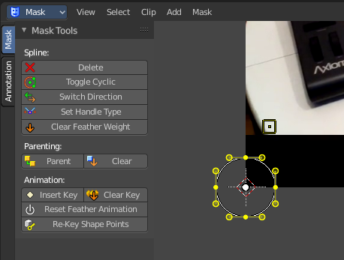
Masks have many purposes. They can be used in a motion tracking workflow to mask out, or influence a particular object in the footage. They can be used for manual rotoscoping to pull a particular object out of the footage. Or as a rough matte for green screen keying. This is done in the Node editor in compositing mode by a mask node.
Masks are independent from a particular image of movie clip. And so they can just as well be used for creating motion graphics or other effects in the compositor.
Masks are defined by splines. Means you work with splines, and you have a bunch of spline tools available.

S-Curves

The curve type used for creating mask splines is almost a Bezier curve. But there are some differences. Smooth edges of the mask are defined by feathering. These are called S-Curves.
Besides the handles, every control point also has points that define the feather between the current point and the next point on the spline. Each feather point is stored in UV space, where U means position across spline segment, and V means distance between main spline and feather points.
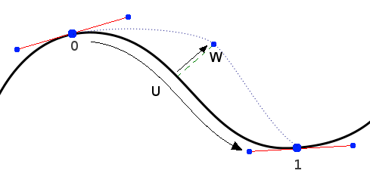
This allows for deforming the main spline in almost any way, and the feather will be updated automatically to reflect that change.
For example if there is just rotation of the spline, feather would stay completely unchanged. If one point’s feather is moved, the other feathers will be automatically stretched uniformly along that segment and the overall shape will be almost the same as artists would want it to be.

Mask Menu

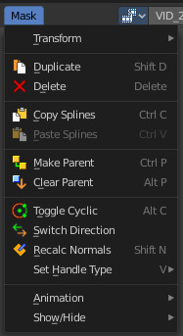

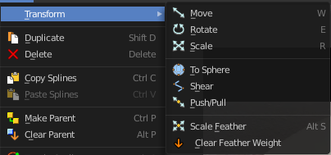
Transform

Move
Move the selected curve spline or points.

Last Operator Move

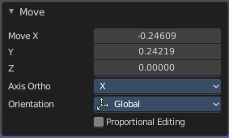
Values
Adjust the move amount.
X, Y and Z defines the position.

Axis Ortho
Along which axis to move.

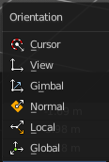
Orientation
Orientation is a drop-down box where you can choose the type of orientation for the transform action.

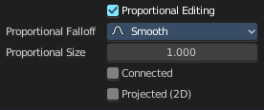
Proportional Editing
Proportional Editing is a drop-down box where you can choose to use proportional editing. When you choose one of the active methods then the neighbor geometry gets influenced too in a proportional way.

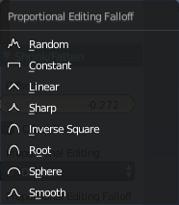
Proportional Editing Falloff
Proportional Editing Falloff is a drop-down box where you can choose a method for the falloff for the proportional editing.

Proportional size
Proportional size is an edit box to Adjust the strength of the Proportional falloff.

Connected
Just edit geometry that is directly connected with the current selection. 4 Bforartists 2 Reference Manual - 7.1.4 Editors - 3D View - Header - Navigation Menu

Projected ( 2D)
Edit geometry that is in 2d space aligned with the current selection. This one goes from the current view in depth direction.

Rotate
Rotate the selected curve spline or points.

Last Operator Rotate

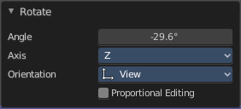
Angle
Adjust the angle.

Axis
Along which axis to rotate

Orientation
Orientation is a drop-down box where you can choose the type of orientation for the transform action.

Proportional Editing
Proportional Editing is a drop-down box where you can choose to use proportional editing. When you choose one of the active methods then the neighbor geometry gets influenced too in a proportional way.

Proportional Editing Falloff
Proportional Editing Falloff is a drop-down box where you can choose a method for the falloff for the proportional editing.

Proportional size
Proportional size is an edit box to adjust the strength of the Proportional falloff.

Connected
Just edit geometry that is directly connected with the current selection. 4 Bforartists 2 Reference Manual - 7.1.4 Editors - 3D View - Header - Navigation Menu

Projected ( 2D)
Edit geometry that is in 2d space aligned with the current selection. This one goes from the current view in depth direction.

Scale
Scale the selected curve spline or points.

Last Operator Resize

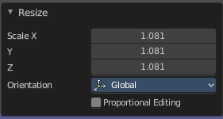
Scale X Y Z
Adjust the scaling.

Orientation
Orientation is a drop-down box where you can choose the type of orientation for the transform action.

Proportional Editing
Proportional Editing is a drop-down box where you can choose to use proportional editing. When you choose one of the active methods then the neighbor geometry gets influenced too in a proportional way.

Proportional Editing Falloff
Proportional Editing Falloff is a drop-down box where you can choose a method for the falloff for the proportional editing.

Proportional size
Proportional size is an edit box to adjust the strength of the Proportional falloff.

Connected
Just edit geometry that is directly connected with the current selection. 4 Bforartists 2 Reference Manual - 7.1.4 Editors - 3D View - Header - Navigation Menu

Projected ( 2D)
Edit geometry that is in 2d space aligned with the current selection. This one goes from the current view in depth direction.

To Sphere
Shapes a selection of objects into the shape of a sphere. The calculation happens with the object origins.
In Object mode this tools requires to have more than one object selected.

Usage

Select the objects, activate the tool, then drag the mouse in the 3D viewport. In the header you will read the current factor then. Which tells you how close you are towards the sphere shape.


Last Operator To Sphere

Factor
The factor to transform the selection into a shape form.


Proportional editing
Enables proportional editing. Activating proportional editing reveals further settings.

Proportional Falloff
Adjust the falloff methods.

Proportional Size
See and adjust the falloff radius.

Connected
The proportional falloff gets calculated for connected parts only.

Projected(2D)
The proportional falloff gets calculated in the screen space. Depth doesn't play a role. When it's in the radius, then it gets calculated.

Shear
Shear shears the selection.
In Object mode this tools requires to have more than one object selected.


Last Operator Shear

Offset
Adjust an offset.

Shear Axis
The shear tool works along a imaginary 2d plane. The shear axis controls if the items are sheared along the x or the y axes of this plane. This is the plane along which the transformation happens. You can shear along the x or the y axis of this plane.
To make things even more complicated, the orientation of this imaginary plane is defined by the Axis and Axis Ortho items below.

Axis
Defines one axis of the imaginary shear axis plane.


Axis Ortho
Defines the other axis of the imaginary shear axis plane.

Orientation
Choose the orientation for the shear action.

Proportional editing
Enables proportional editing. Activating proportional editing reveals further settings.

Proportional Falloff
Adjust the falloff methods.

Proportional Size
See and adjust the falloff radius.

Connected
The proportional falloff gets calculated for connected parts only.

Projected(2D)
The proportional falloff gets calculated in the screen space. Depth doesn't play a role. When it's in the radius, then it gets calculated.

Push/Pull
It pushes or pulls the object positions relative to the center of the selection.
In Object mode this tool requires to have more than one object selected.


Last Operator Push/Pull

Factor
Adjust the strength of influence of the tool.

Proportional editing
Enables proportional editing. Activating proportional editing reveals further settings.

Proportional Falloff
Adjust the falloff methods.

Proportional Size
See and adjust the falloff radius.

Connected
The proportional falloff gets calculated for connected parts only.

Projected(2D)
The proportional falloff gets calculated in the screen space. Depth doesn't play a role. When it's in the radius, then it gets calculated.

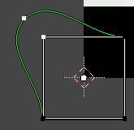
Scale Feather
Scale feather weight for the selected points.
The curve type that is used to create mask splines is almost a Bezier curve. But it has some differences. Smooth edges of the mask are defined by feathering. The curve needed to support feathering in a way that stuck to the curve as you edited it, for ease of editing an animation. These are called S-Curves.
Besides the handles, every control point also has points that define the feather between the current point and the next point on the spline. Each feather point is stored in UV space, where U means position across spline segment, and V means distance between main spline and feather points.

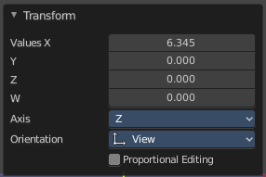
Last Operator Transform

Values
Adjust the scale amount.
X, Y and Z defines the position. W defines the rotation.

Axis
Around which axis to rotate. X, Y or Z.

Orientation
Orientation is a drop-down box where you can choose the type of orientation for the transform action.

Proportional Editing
Proportional Editing is a drop-down box where you can choose to use proportional editing. When you choose one of the active methods then the neighbor geometry gets influenced too in a proportional way.

Proportional Editing Falloff
Proportional Editing Falloff is a drop-down box where you can choose a method for the falloff for the proportional editing.

Proportional size
Proportional size is an edit box to adjust the strength of the Proportional falloff.

Connected
Just edit geometry that is directly connected with the current selection. 4 Bforartists 2 Reference Manual - 7.1.4 Editors - 3D View - Header - Navigation Menu

Projected ( 2D)
Edit geometry that is in 2d space aligned with the current selection. This one goes from the current view in depth direction.

Clear Feather Weight
Reset the feather weight to zero.

Duplicate
Duplicates the selected curve and moves it.

Delete
Deletes the selected mask curve point.

Copy Splines
Copies the currently selected spline.

Paste Splines
Pastes a copied spline.

Make Parent
Set the mask's parenting.

Clear Parent
Clears the mask's parenting.

Toggle Cyclic
Make the spline closed or open.

Switch Direction
Switch the direction in which the spline points. A spline has a direction. A starting point and an endpoint. By switching the starting point becomes the end point, the end point becomes the starting point.

Recalc Normals
Recalculate the direction of the selected spline handlers.

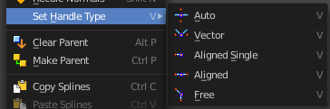
Set Handle Type
In this sub menu you can set the handle type for the currently selected spline points.

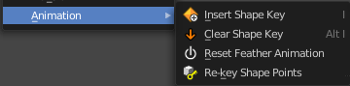
Animation

Insert Shape Key
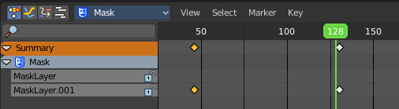
Inserts a shape key keyframe.
The inserted keyframes can then be found in the dope sheet editor in mask mode.

Clear Shape Key
Clears an existing shape key keyframe.

Reset Feather Animation
Resets the feather offset across all animated frames.

Re-key Shape points
Recalculate animation data on selected points for frames selected in the dope sheet.

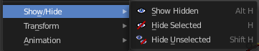
Show / Hide

Show Hidden
Reveals all hidden curves

Hide Selected
Hides the selected curve.

Hide Unselected
Hides the unselected curves.

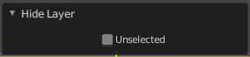
Last operator Hide Layer

Unselected
Hide selected or unselected curves.

